**A Report On Clean Campus Day**

**(1st – 15thSEPTEMBER, 2017)**

The “**Swachhta​ ​Pakhwada**”, as directed by AICTE, is being celebrated in **JECRC​ ​Foundation**, from 1st to 15th September, 2017, under which the following activity has been conducted:

**Clean​ ​Campus​ ​Day -​5thSeptember, 2017**

On this day, a cleanliness drive was organized which was inaugurated by Principal Dr. V.K.Chandna, in the presence of Vice Chairman Shri M.L.Sharma, Senior Advisor Shri O.P.Jain,Coordinator “SOCH” Group Shri Ranjeet Pandey, Activity Coordinator Dr. Barkha Shrivastava and faculty members of Chemistry Department (Organizer of the Clean Campus Day). Members from all departments witnessed the beginning of this clean change. For the cleanliness drive, the campus was divided into four blocks (A,B,C&D). ShriM. L. Sharma, vice chairman JECRC started the drive by distributing gloves to the volunteers.

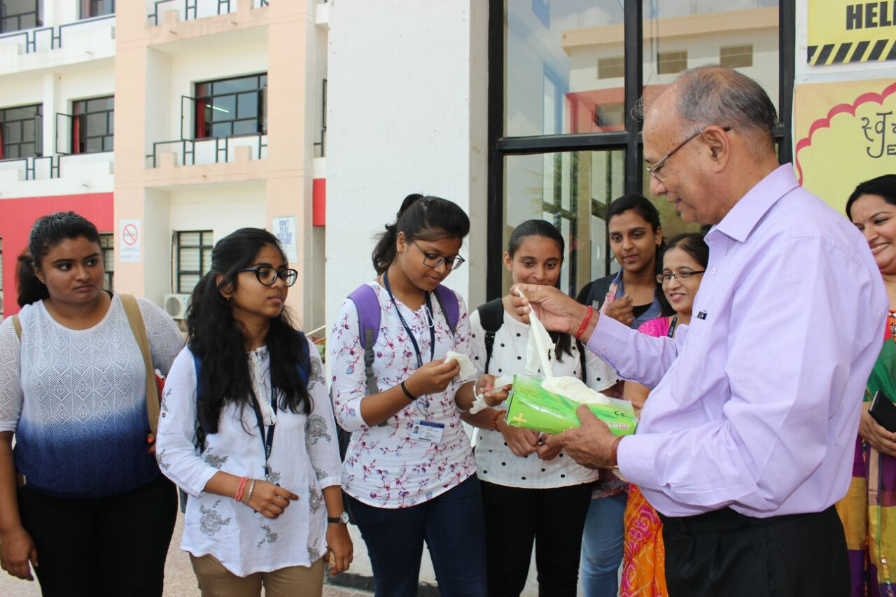

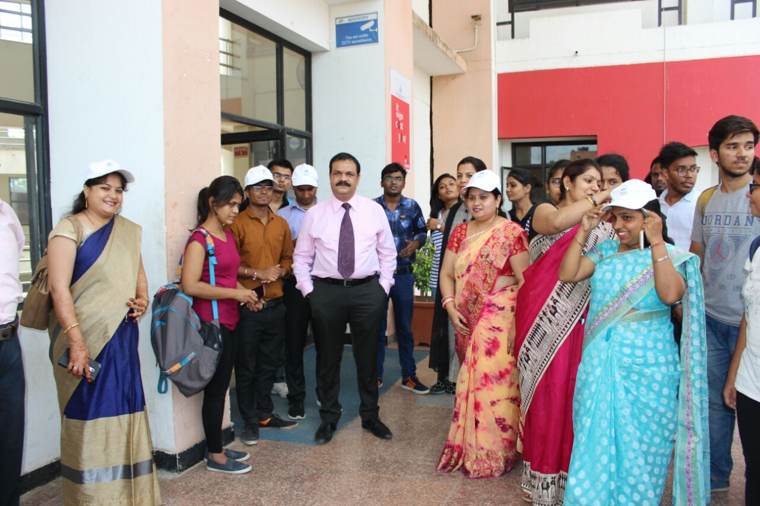

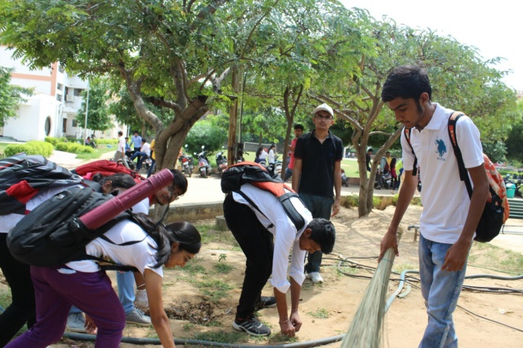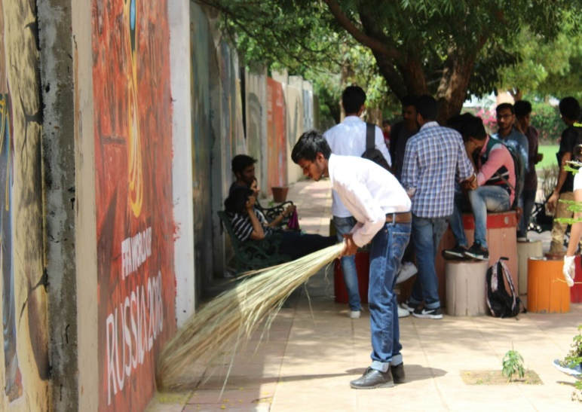They swept the campus and put the garbage in the dustbins kept at various spots in the campus. This event witnessed a humongous participation from 1styear students.

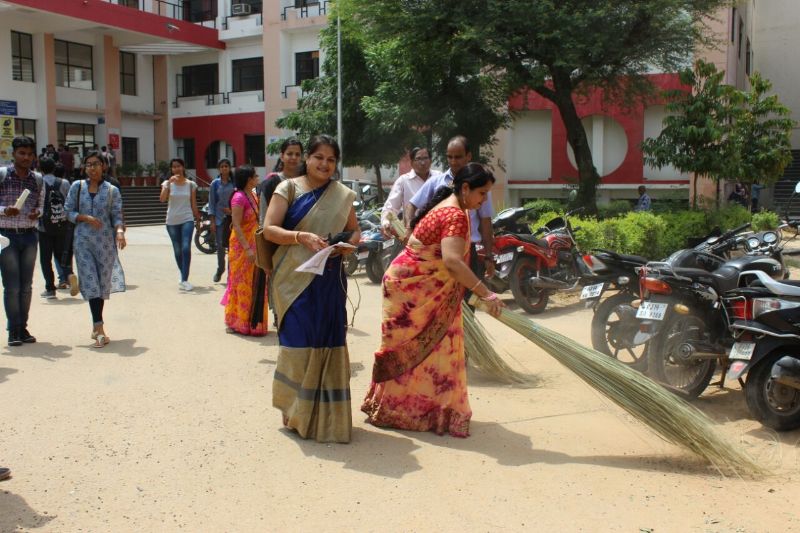

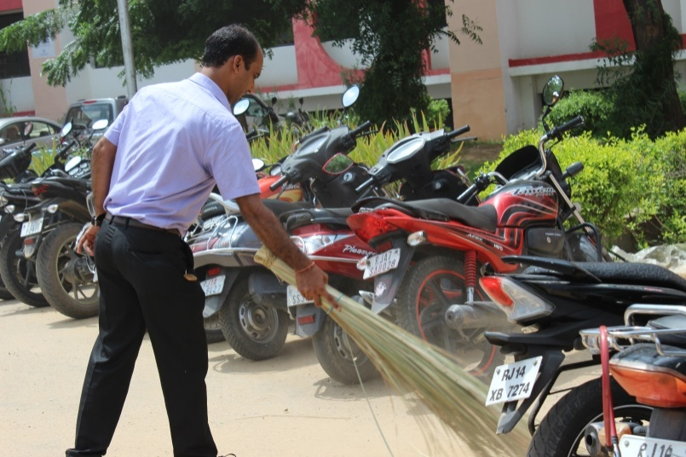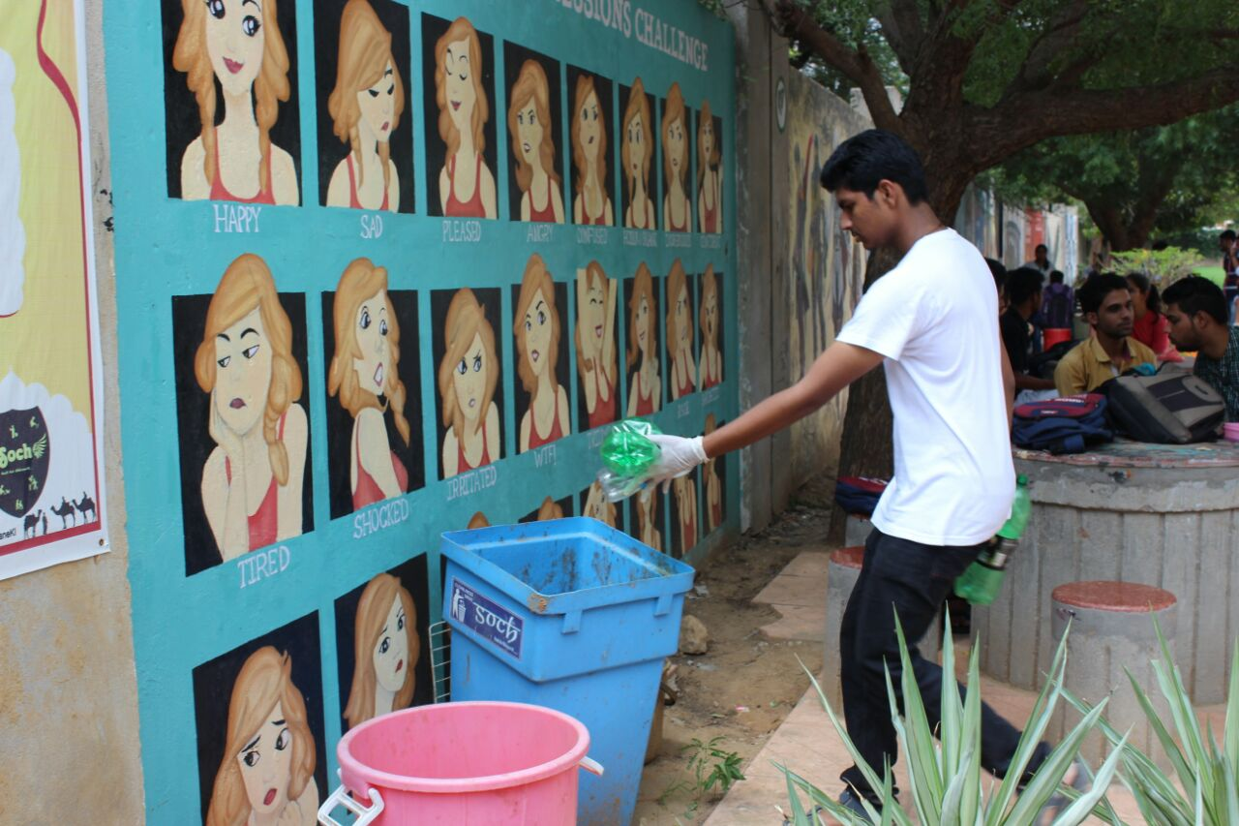

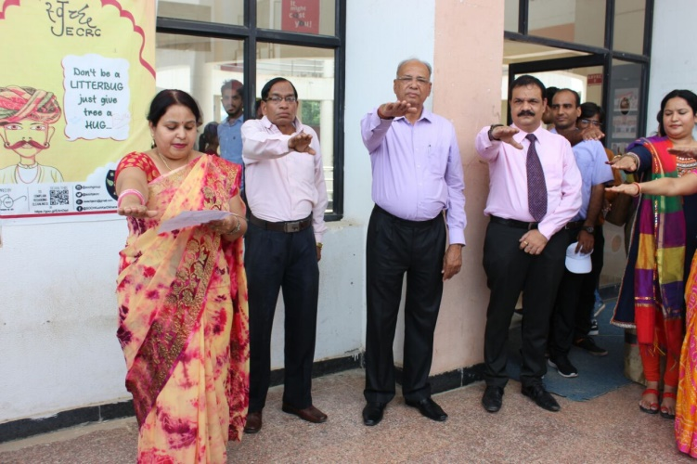

On the same day, a cleanliness pledge was taken in each section of each branch, in which the students resolved to keep the campus, their surroundings and the country clean. The students committed to devote 100 hours of service every year, implying 2 hours per week. The students also took an oath to widespread this message to as many people as possible.

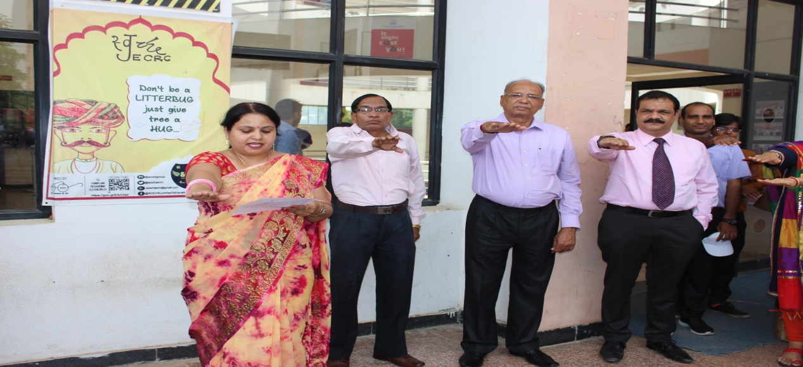

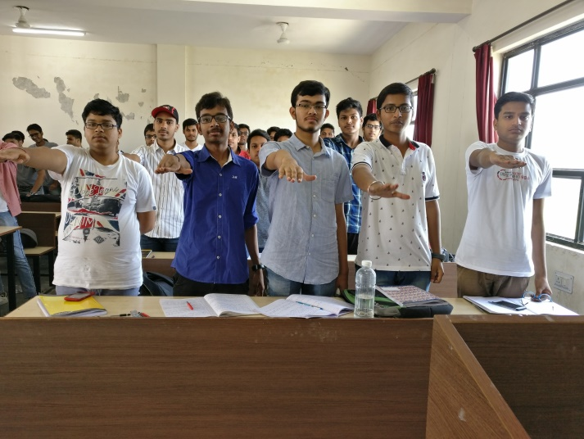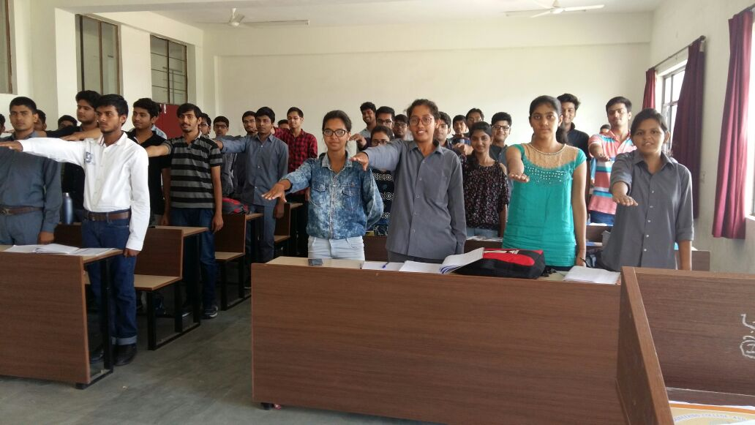

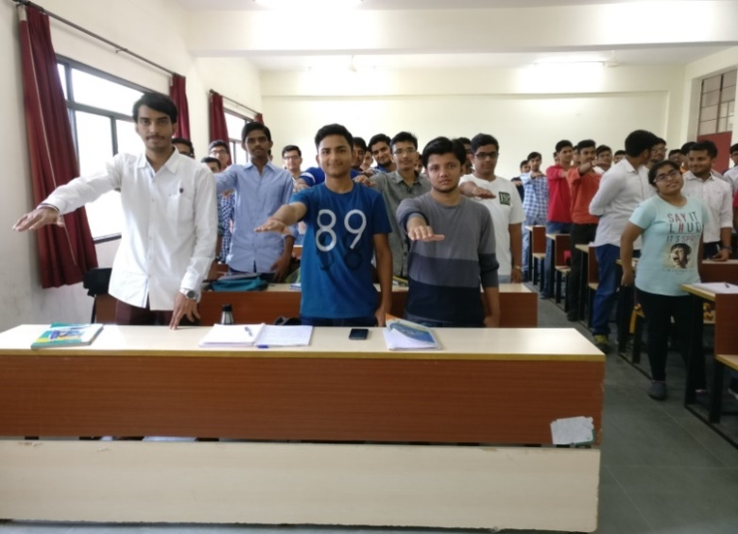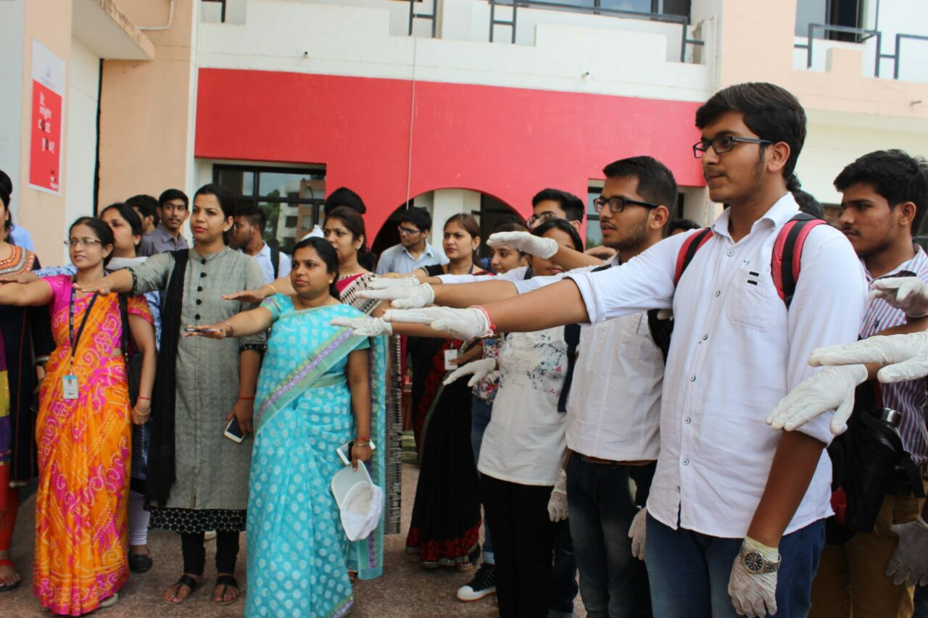

**Cleanliness​ ​March​- 7th March, 2017**

On 7th of September 2017, a ‘Swachhta March’was organized by student of 1st yearunder the supervision of Mr. Shubham Garg (III yr. ME), Mr. Shobhit Vindal (III, Yr. ME) &Mr. Pankaj Maharshi (III Yr., ME) towards the awareness for cleanliness from Block-C to Block-A. This march was inaugurated by Principal Dr. V.K.Chandna, in the presence of Vice Chairman Shri M.L.Sharma, Senior Advisor Shri O.P.Jain, Activity Coordinator Dr. Barkha Shrivastava and faculty members of Chemistry Department.

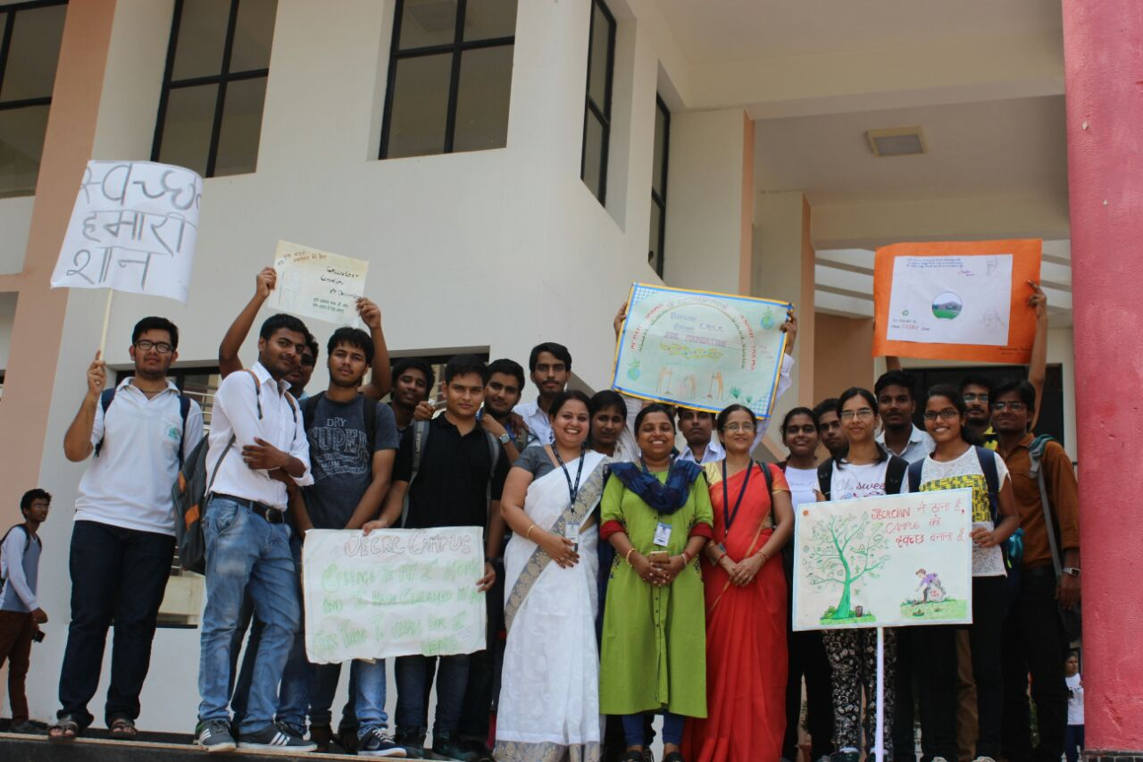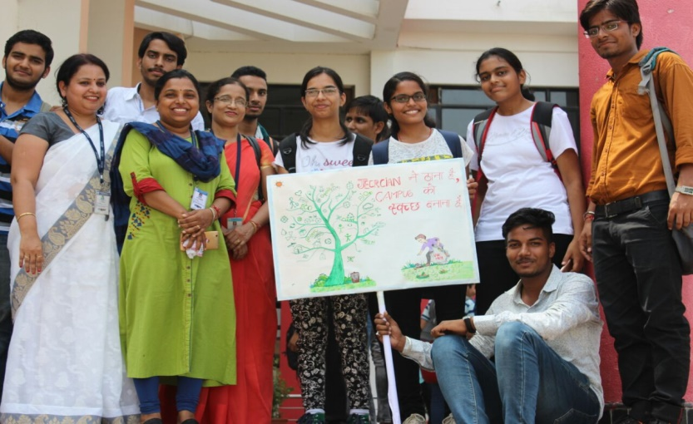

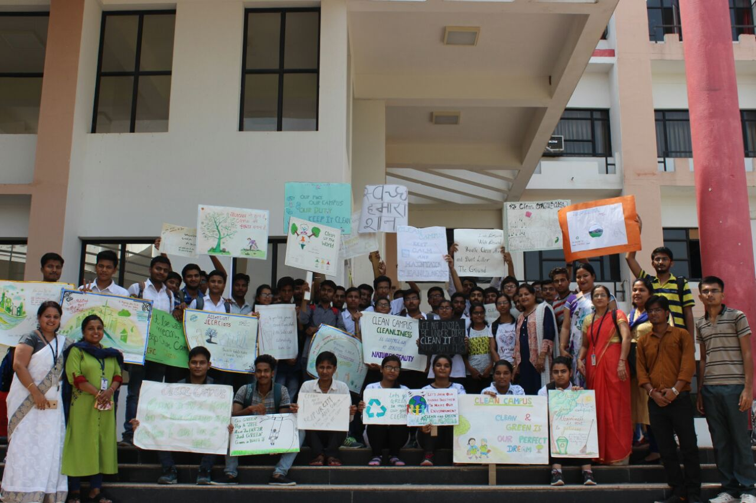

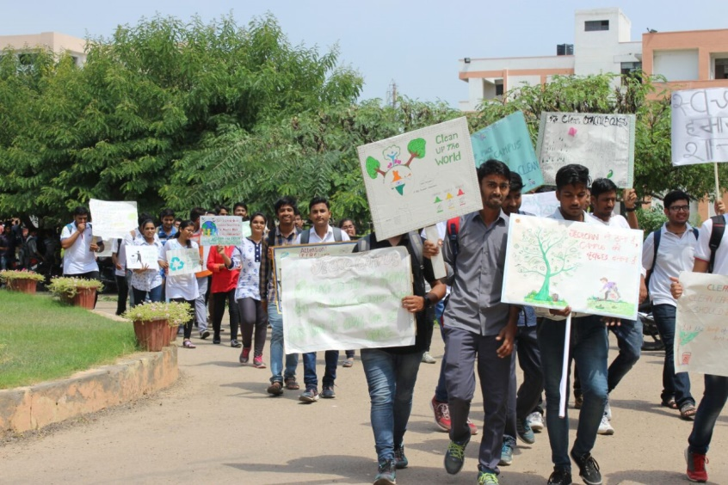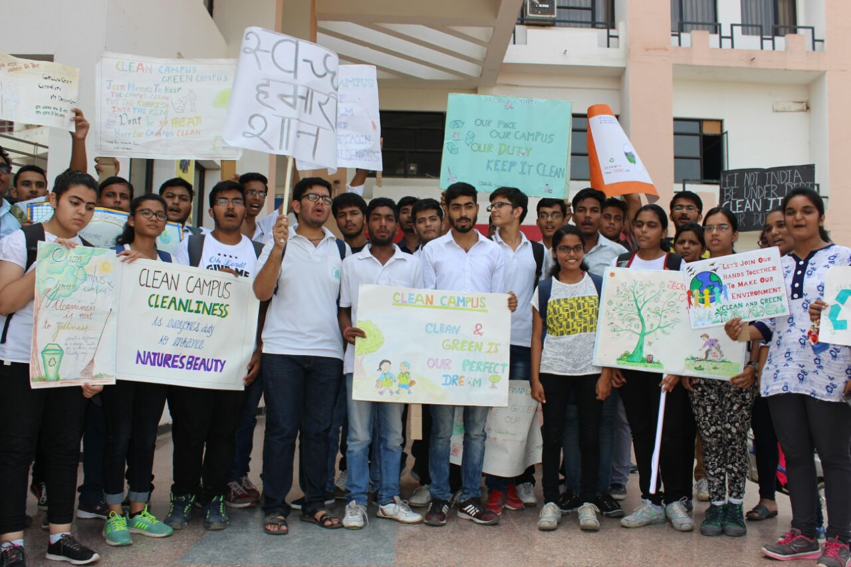 A group of 50 students marched around the campus carrying posters, voicing slogans and spreading awareness about cleanliness. The whole campus heard the cries of **“JECRCian​ ​ne thaana​ ​hai,​ ​campus​ ​ko​ ​swachh​ ​banana​ ​hai”** and many such words that urged the people to keep their surroundings clean and hygienic.

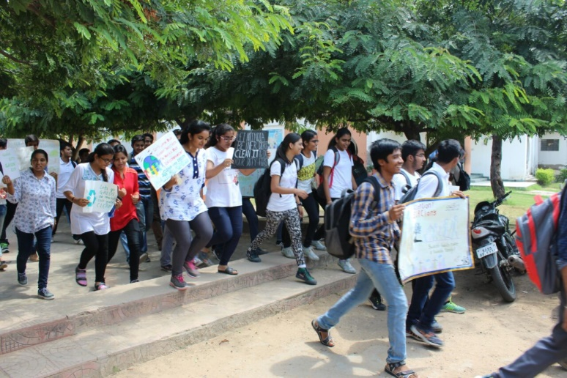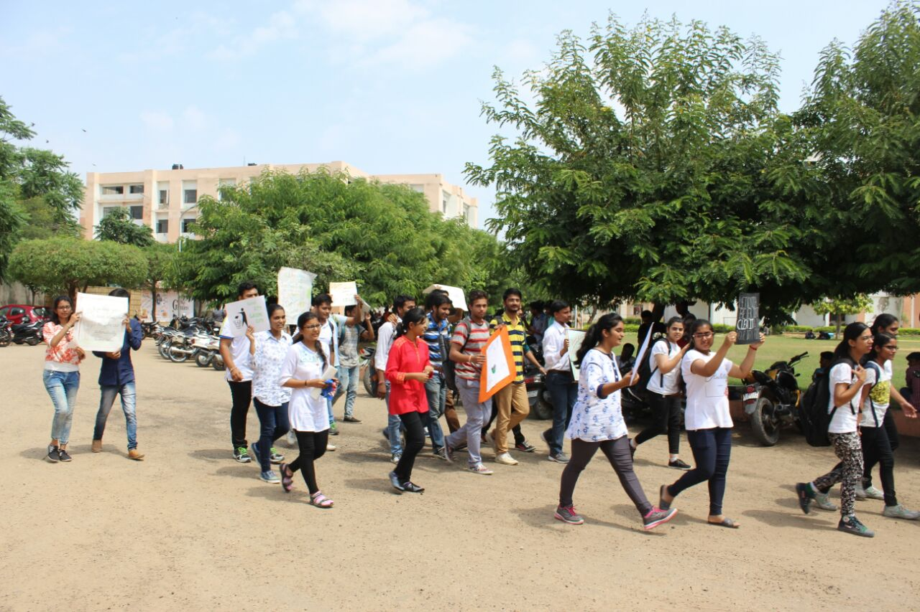

The celebration of the “Swachhata Pakhwada” will end on 15th September 2017. On this day, the closing ceremony will take place, wherein, prizes and certificates will be distributed to the winners and participants. And with a new hope to continue the good work in future,near or far, this festival of cleanliness will be marked successfully completed.